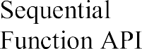







|  |  |
| --- | --- |
|  | 18 November 2022 |
|  | PNT2022TMID36166 |
|  |  |





